PURPOSE/OVERVIEW:

* The purpose of this work instruction is to detail how prices are controlled within the price matrix. Pricing can be changed at all price levels and category types, all at once using this method. This will only change pricing in the price matrix (O-F-3).

RESPONSIBILITIES:

* Customer Service Manager, Customer service reps, Division Operations Supervisors, Sales Manager

PROCESS:

1. The Price matrix is menu option O-F-3. It should not be confused with the quote file which is menu option E-Q. Items listed in the price matrix are considered stock and release. They can also be any item that is not manufactured as run and ship. Items entered as run and ship will reference the quote files. All items sold from our divisions will be in the price matrix only.
2. Prices are pulled from the price matrix into the order once the finished good and quantity to deliver are entered. Prices are pulled into the order as long as the following criteria are met:
   1. A record of the finished good actually exists in the price matrix (O-F-3).
   2. A price is listed in the price matrix (O-F-3).
   3. The category of the record listed matches the same category in the item’s finished good file (O-F-3 category matches category in I-F-1).
   4. The finished good file is checked as “stock item” (not custom) under the view item tab (I-F-1).
3. Export data using the customer field option.
   1. Enter the price matrix (O-F-3). Select the excel icon across the top of page.

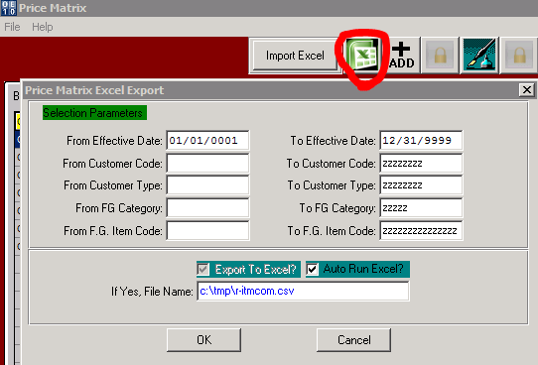

* 1. Make sure to key in a wide range for your effective date. Selecting the example date range above will insure you have every possible price.
  2. Enter the customer code for both “from” and “to” fields.
  3. Leave “From Customer Type” field blank and “To Customer Type” all zzzz’s.
  4. Leave “From FG Category” field blank and “To FG Category” all zzzz’s.
  5. Leave “From FG Item Code” field blank and “To FG Item Code” all zzzz’s.
  6. Select the Auto Run Excel toggle box and click “OK”. It displays all information from each matrix entry.
  7. The data will look something like this:

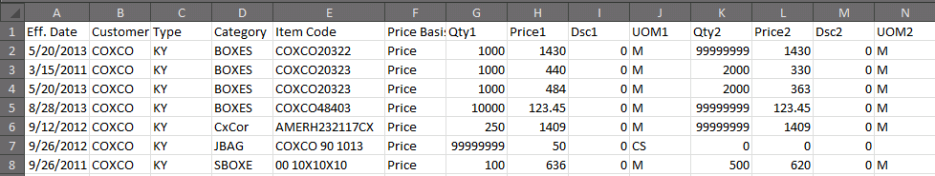

* 1. Notice that the items highlighted in yellow are the same finished good but with two different effective dates.
  2. Also notice the item highlighted in orange only has one price. When an item in the matrix only has one price the QTY entered for that item will automatically change / default to all 99999999’s. You must enter a second QTY and price to keep the first in tact.

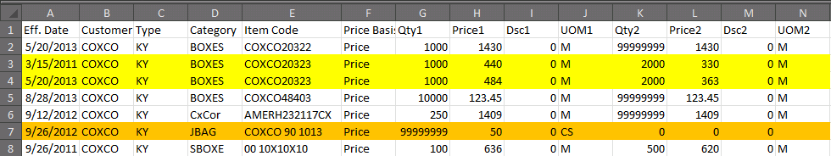

* 1. The file will export as .csv (comma separated value), however, you will need to save this file with .xls or .xlsx extension. Save the file to (desktop, z-folder, common drive, etc...) You will need to access it later in the process.

1. Delete data
   1. Enter the price matrix (O-F-3). Select a random file and click “Delete”.

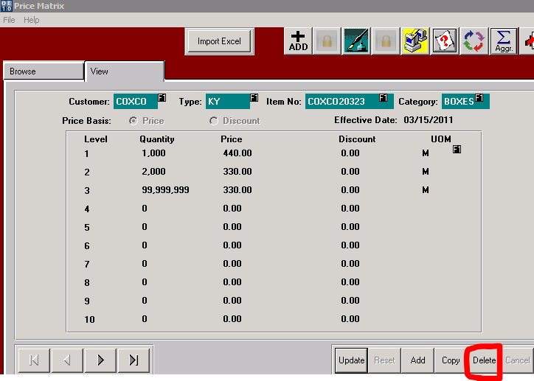

* 1. The “price matrix delete multiple item” box will pop up. It will display the information for the chosen record.

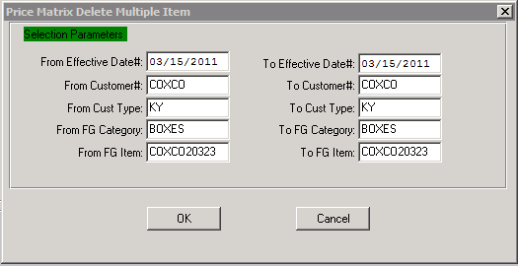

* 1. Update the ranges to delete what is desired. In this example, delete all items under the customer from all categories. If you are updating a specific category from step 3 then you will want to delete the same range of data in this step.

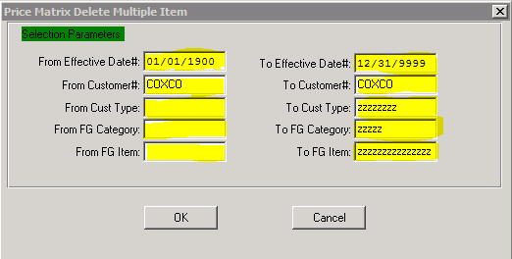

* 1. Make sure to key in a wide range for your effective date. Selecting the example date range above will insure you have every possible record.
  2. Enter the customer code for both “from” and “to” fields.
  3. Leave “From Customer Type” field blank and “To Customer Type” all zzzz’s.
  4. Leave “From FG Category” field blank and “To FG Category” all zzzz’s.
  5. Leave “From FG Item Code” field blank and “To FG Item Code” all zzzz’s.
  6. Click “OK”.

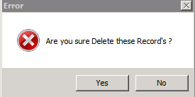

* 1. An error box will prompt to make sure you want to delete. Select Yes.
  2. To confirm your selection has been deleted, look up your search in O-F-3.
  3. The following message will display.

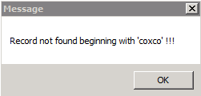

1. Import Data
   1. Update the prices on the record you saved in step 3 k. Open the saved file and make changes to the document with following considerations:
      1. Create a column to the right of each “PRICE#”
      2. Insert a formula such as =H2*1.08. Which means column H, row 2 times 1.08 or an 8% increase.
      3. Copy the formula across all other quantities.

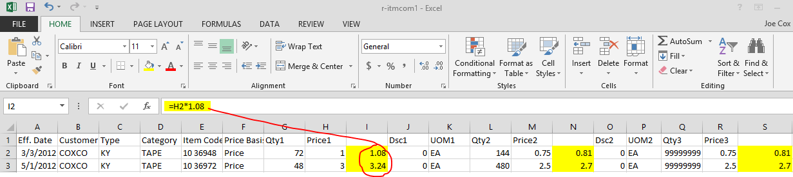

* + 1. Update your effective date as shown below

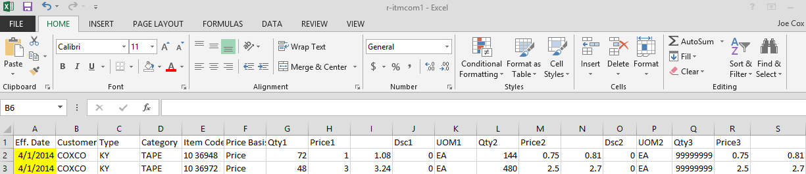

* + 1. Copy prices from the right of the “PRICE#”

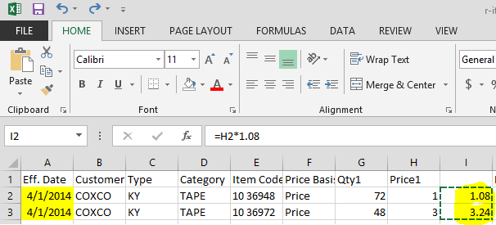

* + 1. Select paste options – values 123 and then delete the column you originally created to the right of “PRICE#”.

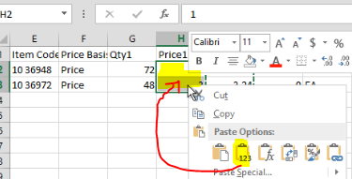

* + 1. To maintain price matrix for current orders and when the new effective price increase goes into effect your sheet will look similar to this.

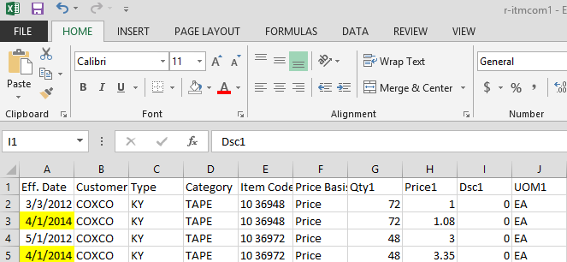

* 1. Enter the price matrix (O-F-3). Click the “import excel” button across the top of the page.

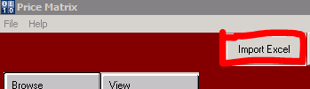

1. Select the document from its saved location.

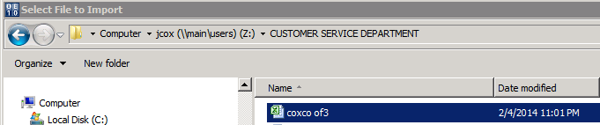

1. Double click the record or click open.
2. The record that you saved and updated is imported back into the price matrix with the updated prices.

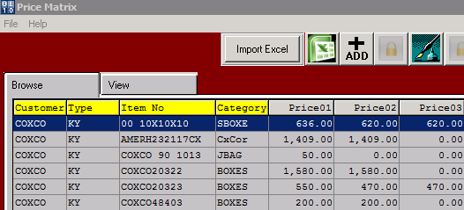

1. The following prompt will confirm the updates or changes to the price matrix.

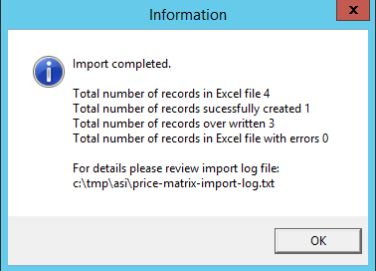

*In this example, only the bottom three records were changed as I only changed prices for the BOXES category*.

**FORMS:**

* Not defined

**RELATED INSTRUCTIONS:**

* 03-WI-13 – UPDATE PRICING SYSTEM

**REVISIONS:**

|  |  |
| --- | --- |
| 04/08/2014 | Initial release |
|  |  |
|  |  |

**APPROVALS:**

Document Owner: Element Owner: Quality Manager: